Winter Field Day 2021 – Dulles Radio ARRL Club
Category: Outdoors
Class: 5 (number of simultaneous transmit stations)
We will ID as “Kilo India 4 Alpha Delta 5 Oscar Virginia” or “KI4AD 5 Oscar Victor Alpha”
Power: 100W or less
Bands and Modes: All Amateur bands and modes except FT8 on HF, VHF, & UHF except 12, 17, 30 and 60 meters. Only 1 Transmitter per band.
Spotting: Prohibited
What to Log: If you have a Windows 10 computer/laptop, I will load the N3FJP Winter Field Day logging software on it for you. We should do this at least the day before the contest. If you are close enough to use the wireless connection, I will share access to a central database to ease log consolidation and avoid duplicates.
If you do not have a Windows 10 computer/laptop to run the N3FJP Winter Field Day logging software, please be sure to capture the following items:
- Other station’s call sign
- Other station’s category
- Other station’s section
- UTC Date and Time
- Band
- Mode
If hand-written logs are used, please be sure data is legible and 11-12-point font size or larger so I can see it. The eyes don’t work as well as they used too.
Bonus points: 1500 bonus points per item below.
- No commercial power is used in powering your WFD station. (Your logging-only computer may use any available power)
- Outdoors
- Not a “Home” operation
- QSO via Satellite. Satellite contacts are limited to ONE ONLY per entry. Multiple contacts will NOT increase score in any way, though, you can help other amateurs make their contacts.
Operational Parameters:
Talk-in
If you are coming to the campus, contact KI4AD on the Dulles Radio ARRL Club 2-meter repeater when you are in route. (145.310mhz, -600 offset, 77hz tone)
On Campus and Shack-to-Shack Comms
To talk between each shack at the site, we will use 147.525 simplex, analog FM.
Scheduled Operators
- Marc – N1BED: HF/VHF/UHF Voice (analog and digital)
- Danny – K4BCR: HF/VHF/UHF Voice (analog and digital)
- Daniel – W5DJV: HF / Digital
- Steve – KS1G: TBD
- Kevin – AK2M: TBD
Note: These are operators for initial set up. All are welcome to bring field sets and operate, or operate the Scheduled Operator positions. There’s plenty of room!
Location
Looking at the map below, considering the land boundaries and the rules of the contest, we need to physically setup inside the area outlined in red. For reference, the map is showing 1,000 feet, diagonal, from corner to corner.
I have outlined where the fire pit is expected to be and where we have scheduled to setup two All-Band voice shacks and antennas. I need feedback from the members who will be bringing their own hardware, as to where you would like to setup inside the operating area. Please let me know if you have an idea of where you would like to setup.
As a quick side note, Evan is having the property cleared in and around the location of antenna number 2. There is also a service road on the northeast part of the property (inside the operation area) that has plenty of space to setup, without bushwhacking to get setup.

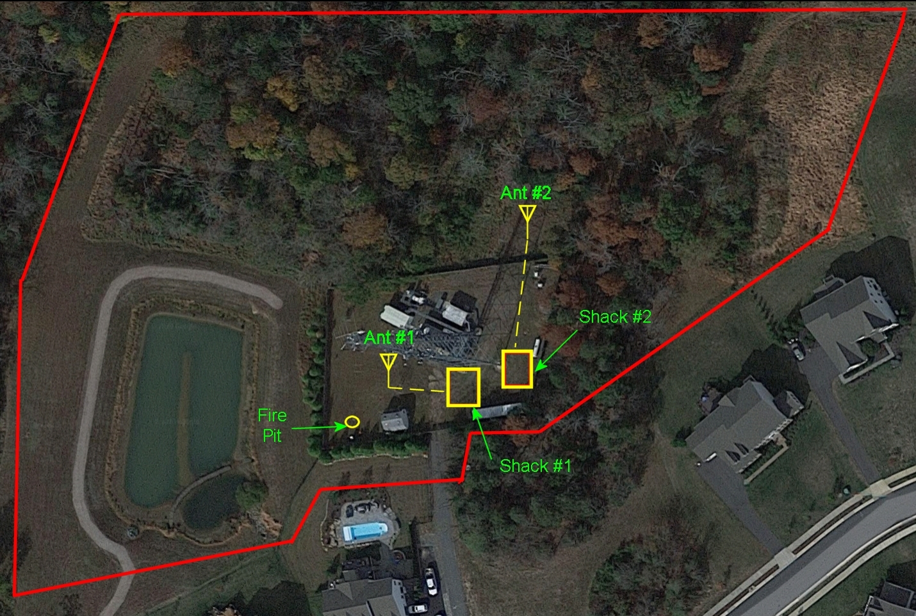

Time Schedule – Note: As Stations are added, the frequency assignments will be adjusted.
Jan 30, 2:00 PM ET to Dusk/Dark
Shack #1 (Danny) – Coordinate Alternate Band Selection W/Team.
UHF SSB Calling / Chasing 432.07 to 432.30
VHF SSB Calling / Chasing 144.200 to 144.275
20m Calling / Chasing
40m Calling / Chasing
Shack #2 (Marc) – Coordinate Alternate Band Selection W/Team.
UHF FM Calling / Chasing 445.500 to 446.500
VHF SSB & FM Calling / Chasing 50.1 to 50.3 and 52.50 to 52.55
10m Calling / Chasing
15m Calling / Chasing
20m Calling / Chasing
Shack #3 (Daniel) – Band Selection At Will
20m Calling / Chasing
Shack #4 (Steve) – TBD
Shack #5 (Kevin) – TBD

Post Twilight to Dawn
Shack #1 (Danny) – Coordinate Alternate Band Selection W/Team.
UHF FM Calling / Chasing 445.500 to 446.500
VHF FM Calling / Chasing 146.450 to 147.525
40m Calling / Chasing
80m Calling / Chasing
Shack #2 (Marc) – Coordinate Alternate Band Selection W/Team.
UHF FM Calling / Chasing 445.500 to 446.500
VHF FM Calling / Chasing 146.450 to 147.525
40m Calling / Chasing
80m Calling / Chasing
Shack #3 (Daniel) – Band Selection At Will
40m Calling / Chasing
80m Calling / Chasing
Shack #4 (Steve) – TBD
Shack #5 (Kevin) – TBD

Sunrise to Jan 31, 2:00 PM ET
Shack #1 (Danny) – Coordinate Alternate Band Selection W/Team.
20m Calling / Chasing
40m Calling / Chasing
Shack #2 (Marc) – Coordinate Alternate Band Selection W/Team.
10m Calling / Chasing
15m Calling / Chasing
20m Calling / Chasing
Shack #3 (Daniel) – Band Selection At Will
20m Calling / Chasing
Shack #4 (Steve) – TBD
Shack #5 (Kevin) – TBD

